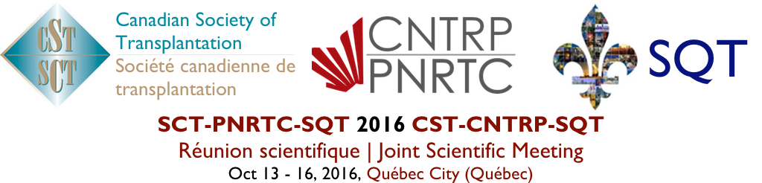

This is to certify that / Le présent certificat atteste que

Name/Nom:

Attended the 2016 CST-CNTRP-SQT Joint Scientific Meeting
a participé à la conférence annuelle 2016 de la Société canadienne de transplantation,
le programme national de recherche en transplantation du Canada et la Société Québécoise de Transplantation

Hours / heures: (max. 34)

This event is an Accredited Group Learning Activity (Section 1) as defined by the Maintenance of Certification program of
The Royal College of Physicians and Surgeons of Canada and approved by the Canadian Association of General Surgeons.

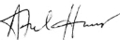 |  | 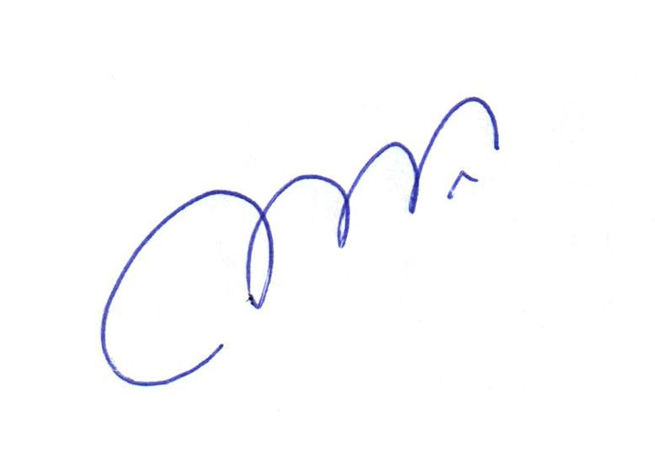
Dr. Atul Humar  President, Canadian Society of Transplantation | Dr. Lori J. West  Director, Canadian National Transplant Research Program | Dr. Michel R. Pâquet  Président, Société Québécoise de Transplantation

114 Cheyenne Way●Ottawa●ON●K2J 0E9●Tel:(877) 968-9449●Fax: (613) 491-0073
admin@cst-transplant.ca ●www.cst-transplant.ca

