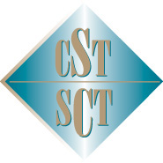
Canadian Society of Transplantation
La Société canadienne de transplantation
October 5 – 10, 2015 / du 5 au 10 octobre 2015

Vancouver, British Columbia

This is to certify that
Le présent certificat atteste que

Name/Nom:

Attended the 2015 Banff Foundation for Allograft Pathology –
Canadian Society of Transplantation Joint Scientific Meeting

Hours / heures: (max. 34)

This event is an Accredited Group Learning Activity (Section 1) as defined by the Maintenance of Certification program of The Royal College of Physicians and Surgeons of Canada and approved by the
Canadian Association of General Surgeons.
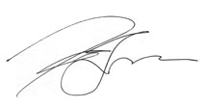 | 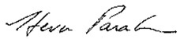
Dr. Kim Solez  President, Banff Foundation for Allograft Pathology | Dr. Steven Paraskevas  President, Canadian Society of Transplantation

114 Cheyenne Way●Ottawa●ON●K2J 0E9●Tel:(877) 968-9449●Fax: (613) 491-0073
admin@cst-transplant.ca ●www.cst-transplant.ca

