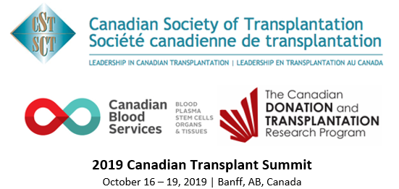

This is to certify that / Le présent certificat atteste que

Name/Nom:

Attended the 2019 Canadian Transplant Summit
a participé à la conférence annuelle 2019 Sommet canadien sur la transplantation

Hours / heures: (max. 30)

This event is an Accredited Group Learning Activity (Section 1) as defined by the Maintenance of Certification program of
The Royal College of Physicians and Surgeons of Canada and approved by the Canadian Association of General Surgeons.
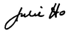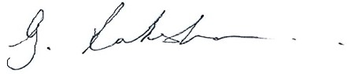
Dr. Julie Ho, Dr. Lakshman Gunaratnam
Co-Chairs, 2019 Canadian Transplant Summit Program Planning Committee

114 Cheyenne Way●Ottawa●ON●K2J 0E9●Tel:(877) 968-9449●Fax: (613) 491-0073
admin@cst-transplant.ca ●www.cst-transplant.ca

