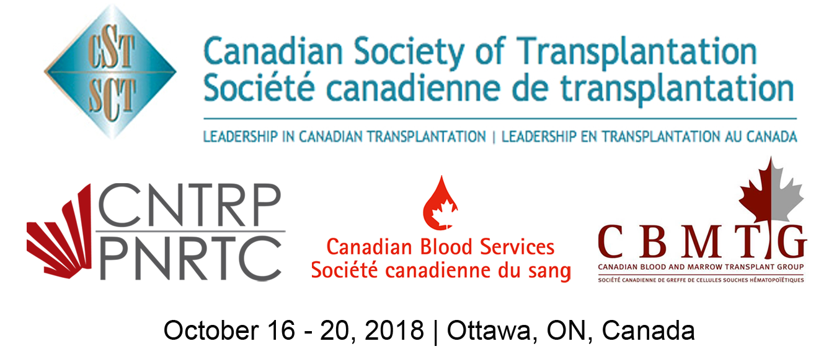

This is to certify that / Le présent certificat atteste que

Name/Nom:

Attended the 2018 Canadian transplant Summit
a participé à la conférence annuelle 2018 Sommet canadien sur la transplantation

Hours / heures: (max. 34)

This event is an Accredited Group Learning Activity (Section 1) as defined by the Maintenance of Certification program of
The Royal College of Physicians and Surgeons of Canada and approved by the Canadian Association of General Surgeons.
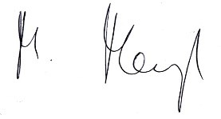
Dr. Michael Mengel
President, Canadian Society of Transplantation

114 Cheyenne Way●Ottawa●ON●K2J 0E9●Tel:(877) 968-9449●Fax: (613) 491-0073
admin@cst-transplant.ca ●www.cst-transplant.ca

